1. Design a web site using HTML, Use Basic text Formatting, Images
<head>
<title>Text</title>
<style>
p{
font-size:18px;
font-family:TIMES NEW ROMAN;
font-weight:bold;
color:blue;
}
</style>
</head>
<body>
<h2 style="color:red">Display the image</h2>
<img src="C:\Users\MAD LAB\Desktop\img8.jpg" width="180px" height="100px"></img> &nbsp;&nbsp;&nbsp;&nbsp;
<img src="D:\2021 Web programming 4th sem\PROGRAMS/wp2.jpg" width="100px" height="150px"></img>&nbsp;&nbsp;&nbsp;&nbsp;
<img src="D:\2021 Web programming 4th sem\PROGRAMS/wp3.jpg" width="80px" height="80px"></img>

<h6>Formatting Text</h6>

<p>This example demonstrates variuos text formatting and display the images</p><br>

font size : <font size="1">HTML</font><br/>
font size : <font size="10">HTML</font><br/>
font color-"red" : <font color="red">HTML</font><br/>
font size-15 and color -red : <font size="6" color="red">HTML</font><br/>
bold,underline and italic : <b><u><i>WEB BOOKS</i></u></b><br/>
Bold :<b>HTML</b><br/>
Strong :<strong>HTML</strong><br/>
Underline :<u>HTML</u><br/>
Italic :<i>HTML</i><br/>
Emapasis :<em>HTML</em><br/>
Strike :<s>HTML</s><br/>
Del :<del>HTML</del><br/>
Highlighting a text :<mark>HTML</mark>
</body>
</html>

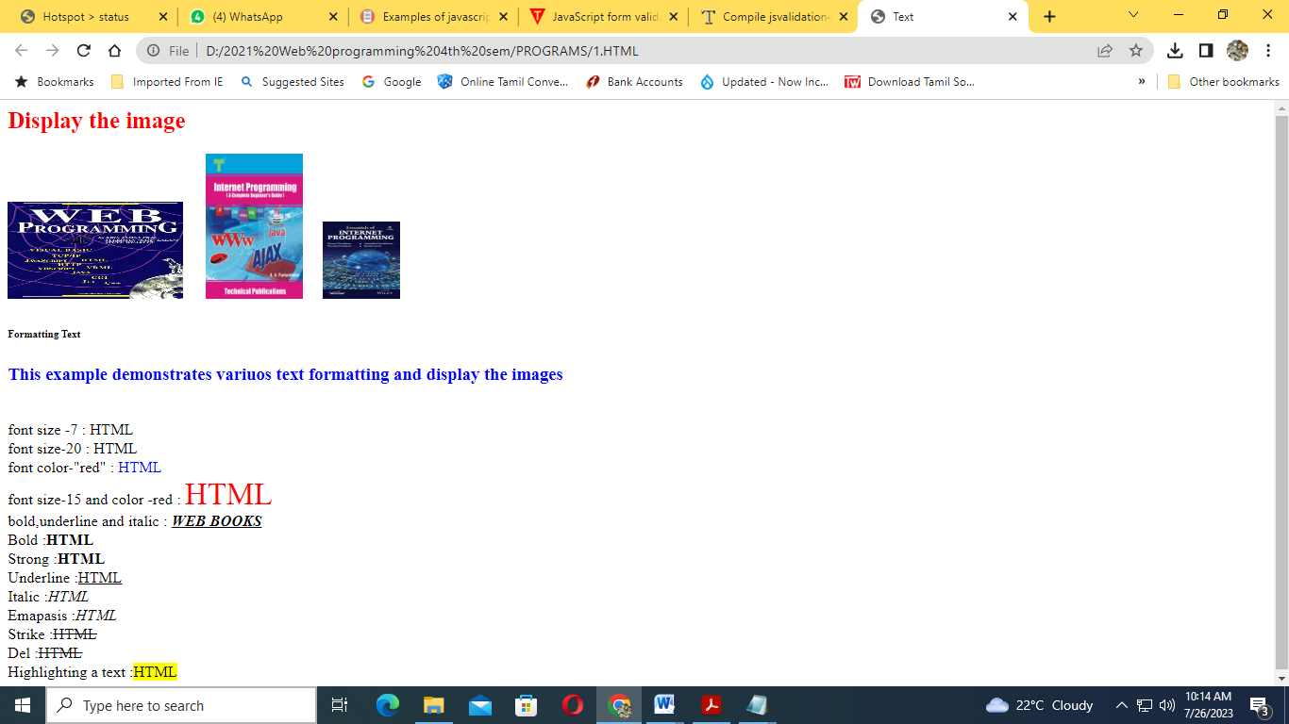

2. Use HTML5 for performing following tasks:
1. Draw a square using HTML5, fill the square with green color and make 6px brown stroke width
2. Write the following mathematical expression by using HTML5 Math ML: d = x2 − y2 .
3. Redirecting current page to another page after 5 seconds using HTML5 Meta tag .
<!DOCTYPE html>
<html>
<head>
<meta charset="utf-8" />
<title>HTML5 Demo</title>
<meta http-equiv="refresh" content="5; URL=http://www.vtu.ac.in">
</head>
<body>
<h3>HTML5 SVG</h3>
<svg width="200" height="200" align="centre">
<rect x="50" y="50" width="100" height="100" fill="green" stroke="orange"
stroke-width="6px"/>
</svg>
<h3>HTML5 MathML</h3>
<math xmlns = "http://www.w3.org/1998/Math/MathML">
<mrow>
<msup><mi>d</mi></msup>
<mo> = </mo>
<msup><mi>x</mi><mn>2</mn></msup>
<mo>-</mo>
<msup><mi>y</mi><mn>2</mn></msup>
</mrow>
</math>
<h3>This page redirects in 5 seconds</h3>
</body>
</html>
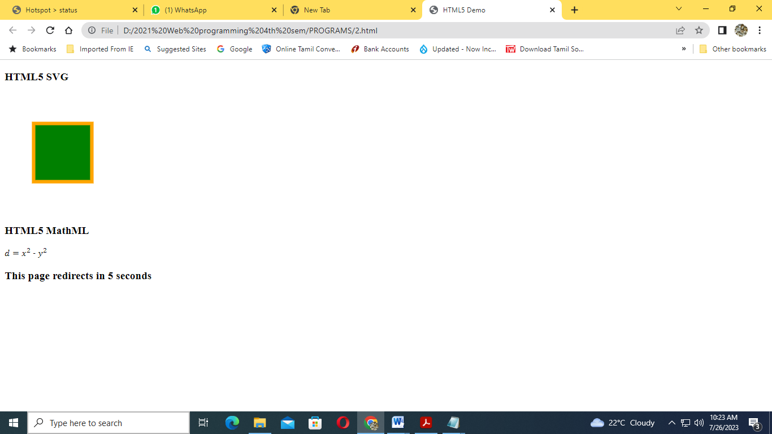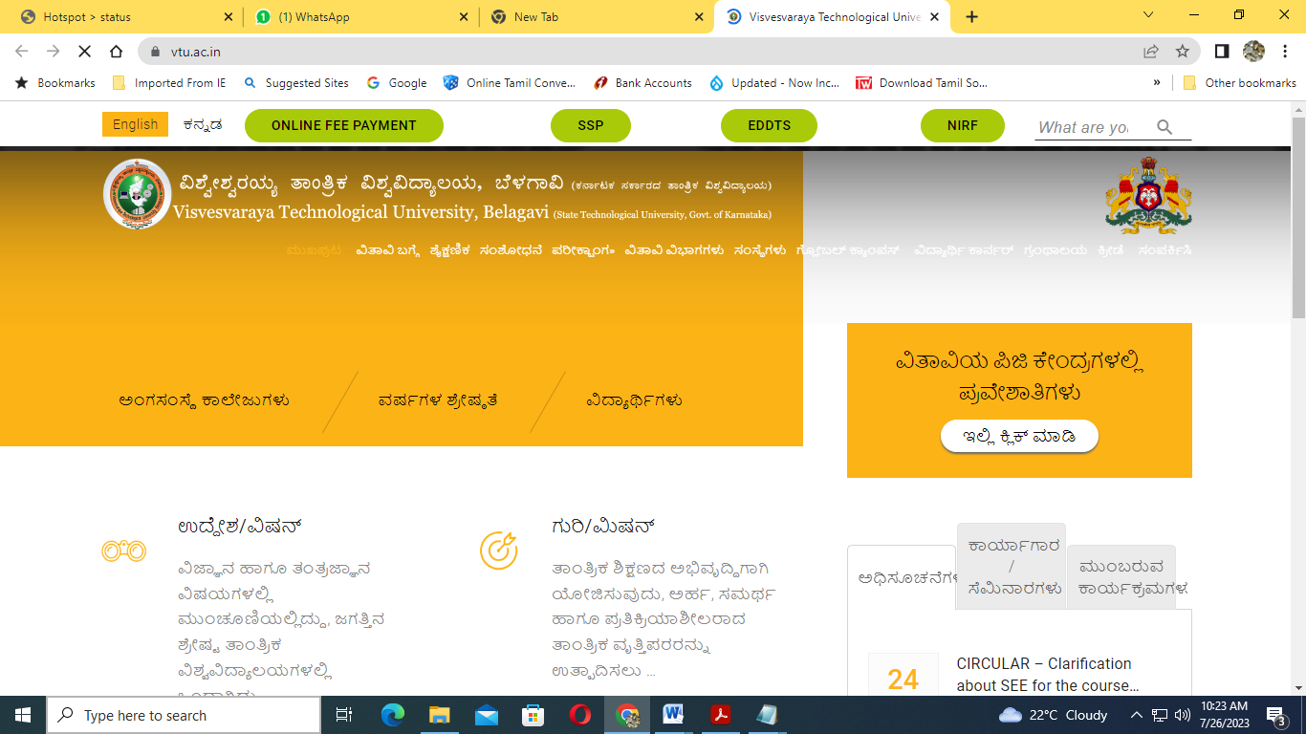

3. Create employee registration webpage using HTML form objects
<html>
<body>
<Center>
<img src="C:\Users\MAD LAB\Desktop\logo.jpg" height=52 width=52>
<Font size="+10" color=red>Employee Registration Form</font>
<form method=post action="prac.html">
<table>
<tr>
<td></td>
<td><input type=radio name=initial checked>Mr.
<input type=radio name=initial>Mrs.
<input type=radio name=initial>Ms.</td>
</tr><tr>
<td>First Name</td>
<td><input type=text name=fn placeholder="First Name"></td>
</tr><tr>
<td>Last Name</td>
<td><input type=text name=ln placeholder="Last Name"></td>
</tr> <tr>
<td>Mail Address1</td>
<td><input type=text name=add1></td>
</tr><tr>
<td>Mail Address2</td>
<td><input type=text name=add2></td>
</tr><tr>
<td>City</td>
<td><input type=text name=ct></td>
</tr><tr>
<td>State</td>
<td><select name=state>
<option value="Gujarat">Gujarat
<option value="Maharastra">Maharastra
<option value="Karnataka">Karnataka
<option value="Delhi">Delhi
</select>
</td>
</tr><tr>
<td>Zip</td>
<td><input type=text name=zp></td>
</tr><tr>
<td>Upload Photo</td>
<td><input type=file name=photo></td>
</tr><tr>
<td>E-Mail</td>
<td><input type=text name=email size=30></td>
</tr><tr>
<td>Mobile</td>
<td><input type=text name=mob placeholder="+91"></td>
</tr><tr>
<td>Languages known</td>
<td><input type=checkbox name=lk value=Gujarati
checked>Gujarati</td>
</tr><tr>
<td></td>
<td><input type=checkbox name=lk value=Hindi
checked>Hindi</td>
</tr><tr>
<td></td>
<td><input type=checkbox name=lk value=English
checked>English</td>
</tr><tr>
<td></td>
<td><input type=checkbox name=lk value=Marathi >Marathi</td>
</tr><tr>
<td>Additional Information</td>
<td><textarea name=add rows=3 cols=20 placeholder="Optional"
wrap></textarea></td>
</tr><tr>
<td></td>
<td><input type=submit value=submit>&nbsp;<input type=reset
value=reset></td>
</table>
</form>
</body> </html>

PRAC.html
<html>
<body bgcolor="orange">
<center>
<img src="C:\Users\MAD LAB\Desktop\up.jpg" height="170"><br>
<font face="Brush Script MT" size="5" color="blue">
<h1><b>submit successfully!!!</b></font><br />
</center>
</body>
</html>
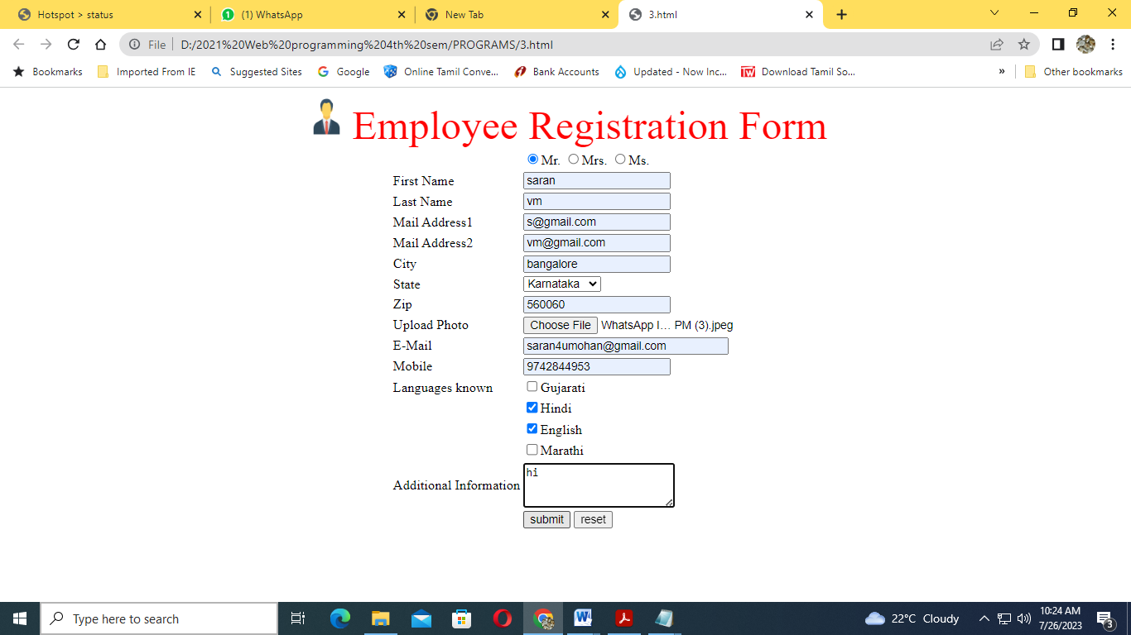

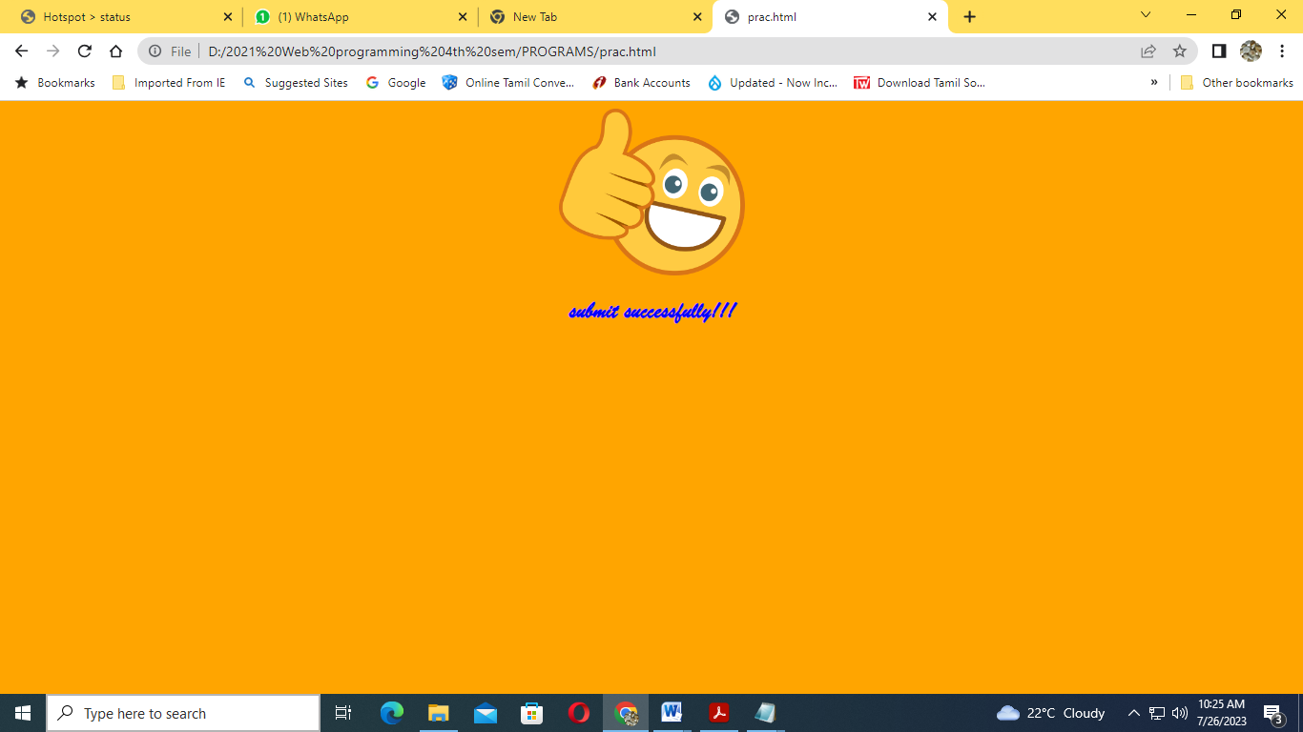

4.Write a JavaScript to design a simple calculator to perform the following operations: sum, product, difference and quotient.

<html>
<head>
<title>My calculator</title>
<script type="text/javascript">
function call(click_id)
{
var v1=parseFloat(document.getElementById("ip1").value);
var v2=parseFloat(document.getElementById("ip2").value);
if(isNaN(v1) || isNaN(v2))
alert("enter a valid number");
else if(click_id=="add")
document.getElementById("output").value=v1+v2;
else if(click_id=="sub")
document.getElementById("output").value=v1-v2;
else if(click_id=="mul")
document.getElementById("output").value=v1*v2;
else if(click_id=="div")
document.getElementById("output").value=v1/v2;
}
</script>
</head>
<body>
<center>
<h1> A SIMPLE CALCULATOR PROGRAM</h1>
<table style="background-color:yellow" align=="center">
<tr>
<td>
<form method="get" action="">
<div width=50% align="center">
<label>OP1<input type="text" id="ip1"/></label>
<label>op2<input type="text" id="ip2"/></label>
<lablel>total<input type="text" id="output"/></label>
</div>
<br>
<div width=50% align="center">
<input type="button" value="+" id="add" onclick="call(this.id)"/>
<input type="button" value="-" id="sub" onclick="call(this.id)"/>
<input type="button" value="*" id="mul" onclick="call(this.id)"/>
<input type="button" value="/" id="div" onclick="call(this.id)"/>
<input type="reset" value="clear"/>
</div>
</form>
</td>
</tr>
</table>
</center>
</body>
</html>

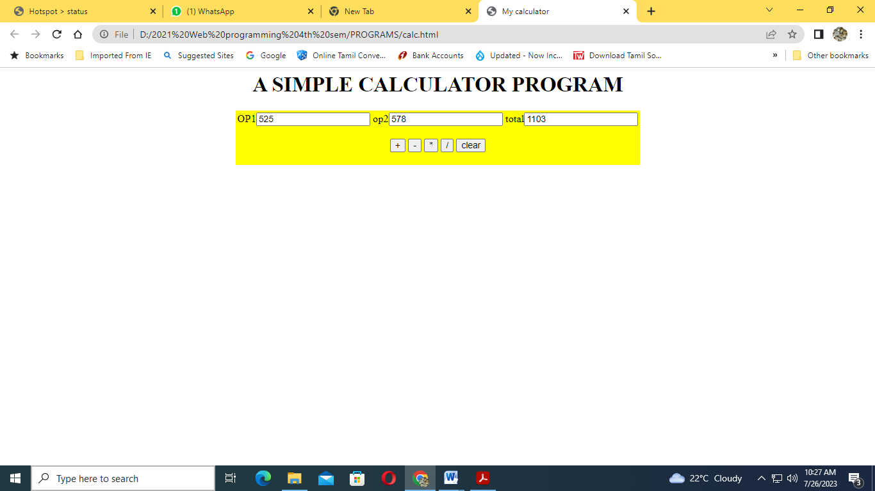

5. Write a program in html using a table col span and row span demonstration of employee table.
<!DOCTYPE html>
<html>
<head>
<style>
table, th, td {
border: 1px solid black;
border-collapse: collapse;
border:double;
}
</style>
</head>
<body>
<h2>COLLSPAN DEMONSTRATION</h2>
<table style="width:40%">
<tr>
<th>EMP ID</th>
<th colspan="2">EMPLOYEE NAME</th>
<th>AGE</th>
<th>SALARY</th>
</tr>
<tr>
<td>001</td>
<td>RAM</td>
<td>KUMAR</td>
<td>43</td>
<td>40000</td>
</tr>
<tr>
<td>002</td>
<td>SHIV</td>
<td>DATTA</td>
<td>50</td>
<td>38000</td>
</tr>
</table></body></html>
ROWSPAN
<!DOCTYPE html>
<html>
<head>
<style>
table, th, td {
border: 1px solid black;
border-collapse: collapse;
}
</style>
</head>
<body>
<h2>ROWSPAN DEMONSTRATION</h2>
<table style="width:40%">
<tr>
<th>EMPLOYEE NAME</th>
<td>RAM KUMAR</td>
</tr>
<tr>
<th rowspan="2">Phone</th>
<td>9886563210</td>
</tr> <tr>
<td>8884901136</td>
</tr><tr>
<th>EMPLOYEE NAME</th>
<td>SHIV DUTT</td>
</tr> <tr>
<th rowspan="2">Phone</th>
<td>9886563210</td>
</tr> <tr>
<td>8884901136</td>
</tr></table></body></html>

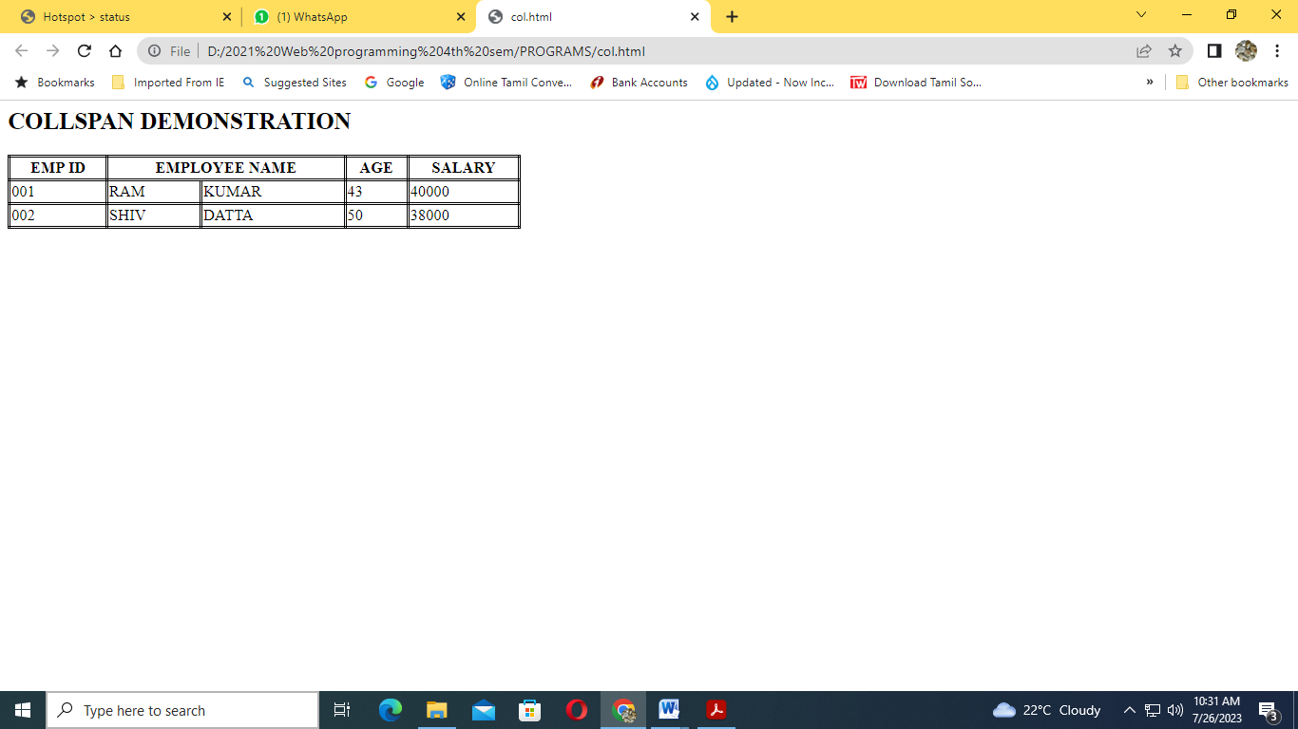

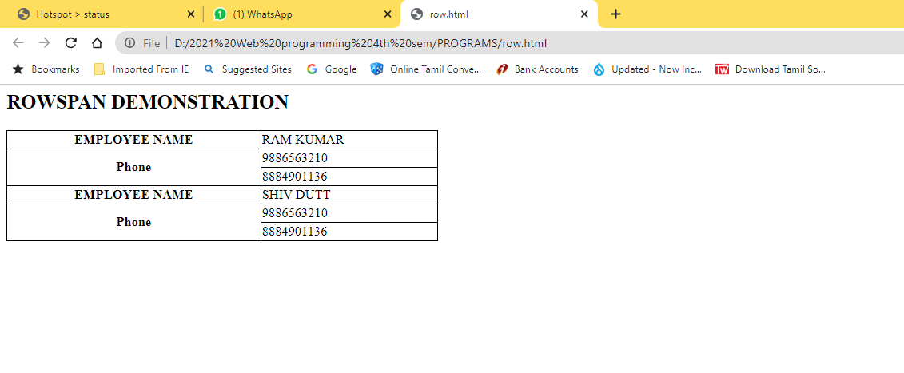
6. Create a webpage containing 3 overlapping images using HTML, CSS and JS. Further when the mouse is over any image, it should be on the top and fully displayed.
<html lang="en">
<head>
<meta charset="utf-8">
<meta name="author" content="Putta" >
<title>Animal Stacking</title>
<style>
h1 {text-align: center;}
.dog {
position: absolute;
left: 10%; top: 10%;
z-index: 0;
}
.cat {
position: absolute;
left: 30%; top: 30%;
z-index: 1;
}
.horse {
position: absolute;
left: 50%; top: 50%;
z-index: 2;
}
</style>
<script>
var topIndex = 2;
function moveToTop(picture) {
picture.style.zIndex = ++topIndex; }

</script>
</head>
<body>
<h1>Image Overlap Demo</h1>
<div id="image-container">
<img id="dog" class="dog" src="D:\2021 Web programming 4th sem\PROGRAMS\dog.jpg" onmouseover="moveToTop(this)" width="
400" height="300">
<img id="cat" class="cat" src="D:\2021 Web programming 4th sem\PROGRAMS\cat.jpg" onmouseover="moveToTop(this)" width="
400" height="300">
<img id="horse" class="horse" src="D:\2021 Web programming 4th sem\PROGRAMS\horse.jpg" onmouseover="moveToTop(this)"
width="400" height="300">
</div>
</body>
</html>
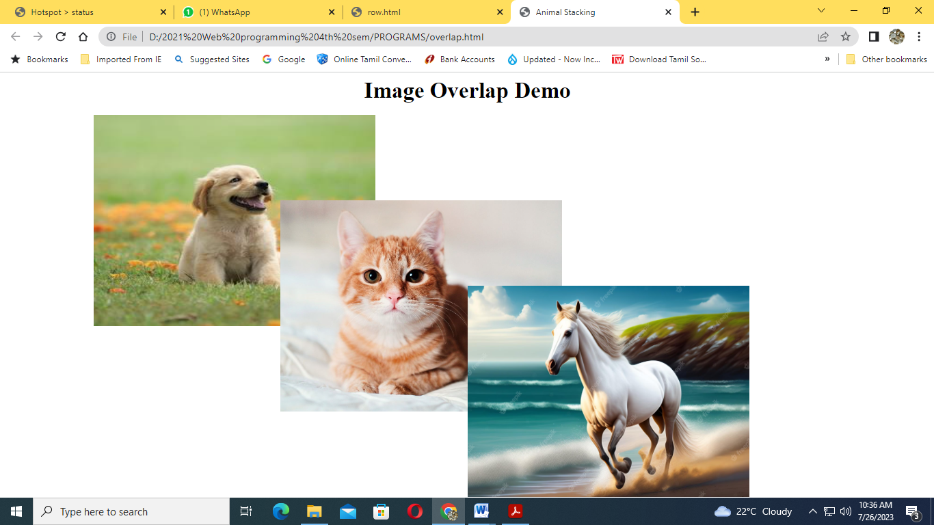
7. Write a JavaScript that calculator the squares and cubes of the numbers from 0 to 10 and outputs HTML text that displays the resulting values in an HTML table format.
<html>
<head>
</head>
<body>
<table align="center" border=5>
<tr><td>number</td><td>square</td><td>cube</td></tr>
<script type="text/javascript">
for(var n=0; n<=30; n++)
{
document.write( "<tr><td>" + n + "</td><td>" + n*n + "</td><td>" + n*n*n
+ "</td></tr>" ) ;
}
</script>
</table>
</body>
</html>

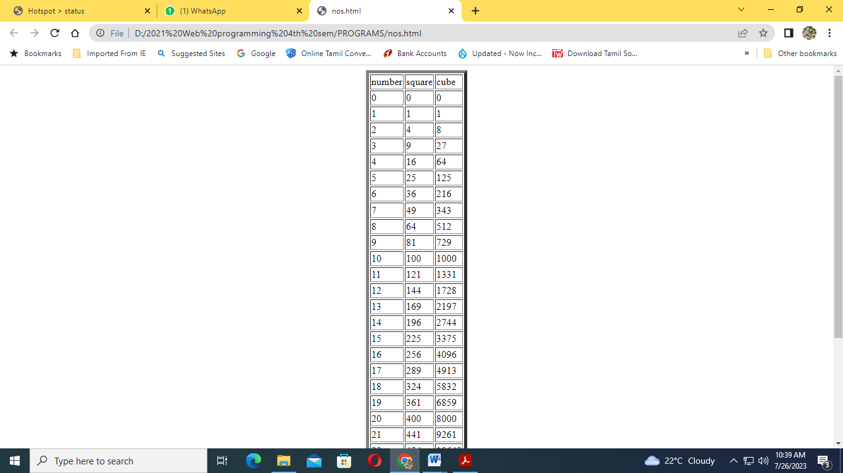

8. Write an HTML page including JavaScript that takes a given set of integer numbers and shows them after sorting in descending order.
<html>
<head>
<title>Number in Descending Order</title>
<script language="javascript">
function ndesc()
{
var num_array=new Array();
var num=document.forms["frm1"].num.value;
document.forms["frm1"].desc.value="";
var nums = num.split(',');
var len=num.split(',').length;
for(var i=0;i<len;i++)
{
num_array.push(nums[i]);
}
function sortN(a,b)
{ return b - a;
}
document.forms["frm1"].desc.value= num_array.sort(sortN);
}
</script>
</head>
<body>
<form name="frm1">
<center>
<h3> Numbers in Descending Order</h3>
</center>
<br/>
<center>Enter Numbers separated by Comma : <input type="text" name="num"</input><br/></center>
<br/>
<center>
<input type="button" name="inwords" value="In Descending Order" onclick="ndesc()"></input>
</center>
<br/><br/>
<center>Number in Descending Order : <input type="text" name="desc"</input></center>
<br/>
</form>
</body>
</html>
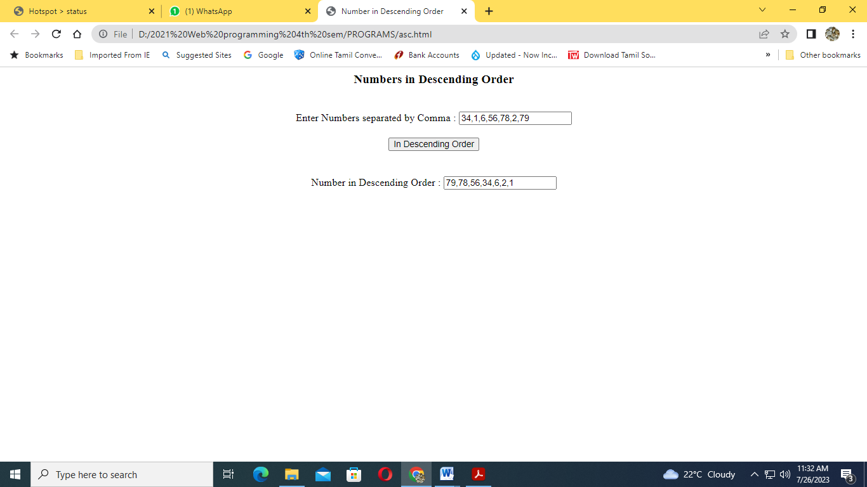

9.Create following table using XHTML tags. Properly align cells, give suitable cell padding and cell spacing, and apply background color, bold and emphasis necessary
<html xmlns="http://www.w3.org/1999/xhtml" xml:lang="en">
<head>
<title>Table Demo XHTML PAGE</title>

<style>
table, th, td {
border: 1px solid black;
border-collapse: collapse;
}
th, td{
padding-left: 10px;
padding-bottom: 20px
}
table {
border-spacing: 30px;
}
</style>

</head>
<body>
<h3>Tables in XHTML</h3>

<table align="center" width="70%" style="height:450px">
<tr >
<td rowspan="9" align="center" bgcolor=DFFFFF>
<b>Department</b>
</td>
<td rowspan="3" align="center" bgcolor=9E7BA0>
<b>Sem1</b>
</td>
<td padding:15px>
<em>SubjectA</em>
</td>
</tr>
<tr>
<td ><em>SubjectB</em></td>
</tr>
<tr>
<td ><em>SubjectC</em></td>
</tr>

<tr>
<td rowspan="3" align="center" bgcolor=9E7BA0>
<b>Sem2</b>
</td>
<td ><em>SubjectE</em></td>
</tr>
<tr>
<td ><em>SubjectF</em></td>
</tr>
<tr>
<td ><em>SubjectG</em></td>
</tr>

<tr>
<td rowspan="3" align="center" bgcolor=9E7BA0>
<b>Sem3</b>
</td>
<td ><em>SubjectH</em></td>
</tr>
<tr>
<td ><em>SubjectI</em></td>
</tr>
<tr>
<td ><em>SubjectJ</em></td>
</tr>

</table>

</body>
</html>

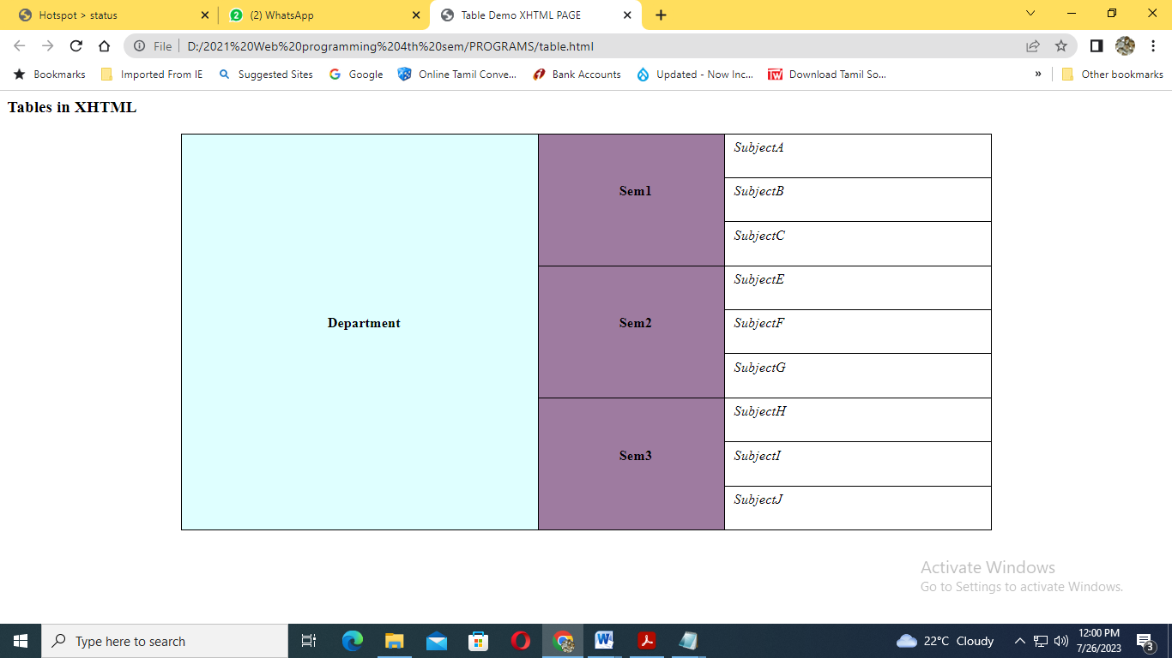

10. Write a HTML program for creating a class time-table by using tables.
<html>
<head>
<title>Timetable</title>
</head>
<body>
<h1 align="center"><font color="Salmon">Timetable of III
CSE</font></h1><br>
<table align="center" border="2" cellspacing="0" cellpadding="15">
<tr align="center" valign=="middle">
<th>DAY</th>
<th>I</th>
<th>II</th>
<th
rowspan="7"><b>T<br>E<br>A<br><br>B<br>R<br>E<br>A<br>K</b></th>
<th>III</th>
<th>IV</th>
<th
rowspan="7"><b>L<br>U<br>N<br>C<br>H<br><br>B<br>R<br>E<br>A<br>K</
b></th>
<th>V</th>
<th>VI</th>
<th>VII</th>
</tr>
<tr align="center">
<th>MON</th>
<td>IS</td>
<td>WT</td>
<td>SEM</td>
<td>OOAD</td>
<td>SCI</td>
<td>C#</td>
<td>COMP</td>
</tr>
<tr align="center">
<th>TUE</th>
<td>AP</td>
<td>AP Lab</td>
<td colspan="2">AP Lab</td>
<td>WT</td>
<td>IS</td>
<td>OOAD</td>
</tr>
<tr align="center">
<th>WED</th>
<td>WT</td>
<td>IS</td>
<td>C#</td>
<td>SCI</td>
<td colspan="3">MOOC'S</td>
</tr>
<tr align="center">
<th>THU</th>
<td>IS</td>
<td>LIB</td>
<td>OOAD</td>
<td>WT</td>
<td colspan="3">WT Lab</td>
</tr>
<tr align="center">
<th>FRI</th>
<td>AP</td>
<td>AP</td>
<td>C#</td>
<td>OOAD</td>
<td colspan="3">C# Lab</td>
</tr>
<tr align="center">
<th>SAT</th>
<td>OOAD</td>
<td>SCI</td>
<td>WT</td>
<td>SEM</td>
<td>AP</td>
<td>AP</td>
<td>C#</td>
</tr>
</table>
</body>
</html>

